AerGate:
Autonomous air quality control and window automation system

Organization: Kazakhstan, Astana, Quantum Stem school
Authors: Alimzhan Almir, Yagmurov Alen
Field: computer science/ engineering
Section: hardware control
Mentor: Altynbek Medetkhan
City: Astana, Kazakhstan
Year: 2026

Abstract 2
Introduction 3
Research section 4
Conclusion 8
References for Analytical Review: 9

Abstract

The objective of this research is to design and implement an autonomous hardware–software system capable of monitoring indoor carbon dioxide (CO₂) levels and automatically controlling window opening and closing in order to improve indoor environmental quality and human well-being. The hypothesis of the study is that automatic regulation of ventilation based on real-time CO₂ concentration can maintain healthier air conditions while reducing the need for constant human intervention.
The research was carried out in several stages. First, existing solutions for indoor air-quality monitoring and ventilation control were analyzed. Next, a hardware system consisting of a gas sensor, microcontroller, motor driver, stepper motor, and display module was designed and assembled. After that, control software was developed to process sensor data, evaluate air-quality conditions, and generate control signals for the mechanical system. Finally, the system was tested under different environmental conditions.
The methodology of the experiment is based on continuous acquisition of analog sensor data, normalization of the measured values, and decision-making using predefined threshold levels with hysteresis to ensure stable operation. The novelty of the research lies in the integration of a low-cost sensor-based monitoring system with autonomous mechanical window control. The project was developed independently, including circuit assembly, programming, and system testing.
The results demonstrate stable and reliable operation of the system, with effective response to changes in CO₂ levels. The proposed solution can be practically applied in homes, classrooms, and offices to improve air quality, support human health, and enhance overall comfort.

Introduction

Indoor air quality has a significant influence on human health, cognitive performance, and overall well-being. In modern buildings, especially in residential spaces, schools, and offices, insufficient ventilation often leads to increased concentrations of carbon dioxide (CO₂). Elevated CO₂ levels are associated with fatigue, reduced concentration, headaches, and a general decline in comfort. Despite this, ventilation is frequently managed manually, which makes it inconsistent and dependent on human attention and habits. As a result, there is a clear need for automated solutions that can maintain healthy indoor air conditions in an efficient and reliable manner.
The relevance of this research is determined by the growing demand for smart environmental control systems that improve living conditions while minimizing human effort. Autonomous systems capable of monitoring air-quality parameters and responding to them in real time represent an important direction in modern hardware control and smart building technologies. In this context, the automatic regulation of indoor CO₂ levels is a practical and socially significant task.
The objective of this work is to develop an autonomous system that monitors carbon dioxide levels and controls the opening and closing of a window based on measured air-quality conditions. To achieve this objective, several tasks were defined: analyzing existing approaches to air-quality control, designing a hardware system for sensing and actuation, developing control software for decision-making, and testing the system under varying environmental conditions.
The methods used to solve these tasks include sensor-based data acquisition, microcontroller programming, implementation of threshold-based control algorithms, and experimental verification of system operation. These methods allow the system to function autonomously and respond effectively to changes in indoor air quality.

Research section

2.1 Analytical Review of Existing Solutions
Indoor air quality is a major factor influencing human health, productivity, and well-being. Several automated air-quality systems have been developed to regulate indoor CO₂ concentration. For example, Li et al. (2020) designed a smart ventilation system that opens and closes windows based on CO₂ levels using Arduino-based sensors [1]. Similarly, Smith and Johnson (2019) proposed an IoT-enabled air-quality monitoring system that controls mechanical ventilation in classrooms and offices [2]. These solutions demonstrate the feasibility of using low-cost sensors combined with microcontrollers to maintain safe and comfortable indoor environments. However, most systems rely on pre-existing building HVAC infrastructure or are limited in portability. Also, we have found that these systems are not compatible with the windows in our school, giving us the idea to create something that would work. Our project focuses on a compact, self-contained, autonomous window control system suitable for prototyping and educational demonstration.

2.2 Hardware System Description
The hardware system was developed using a Raspberry Pi Pico microcontroller as the central controller. The components were selected to allow autonomous monitoring, actuation, and user feedback. The Bill of Materials (BOM) is listed below:
Component | Role in project | Specifications
Raspberry Pi Pico | Main controller | Dual- core RP2040 processor; handles sensor reading and actuator control
MQ-135 Sensor | Air quality sensor | Detects CO2, provides analog output
NEMA 17 Stepper Motor | Window actuator | High torque and precision for window movement
L298N Motor Driver | Motor driver | Allows Pico to control stepper motor with external power
I2C LCD 1602 | Display | Shows real-time air quality (%) and window status

Peripherals:
•Buzzer (passive) – Audible alert at 4000 Hz before and during window actuation
•NPN Transistor (BC547) – Switches buzzer power (Pico outputs 3.3 V)
•Resistor (470 Ω) – Protects transistor and Pico pin
•Status LED – Visual indicator during operation or alert
•Breadboard & Jumper Wires – Flexible prototyping without soldering
Power Supply
•12V DC Adapter – Powers stepper motor via L298N
•9V Battery / Step-down Converter – Powers buzzer
•Micro-USB Cable – Powers Raspberry Pi Pico
Mechanical Components
•Rack and Pinion – 3D-printed gear and rack converts rotation into linear motion
•Prototype Frame – Wood/plastic frame simulating a window opening
The system separates power between the Pico logic and the motor to prevent interference and protect the controller, which demonstrates professional engineering practice.
Functional block diagram of the AerGate system showing the interconnection between the control unit, sensors, and actuators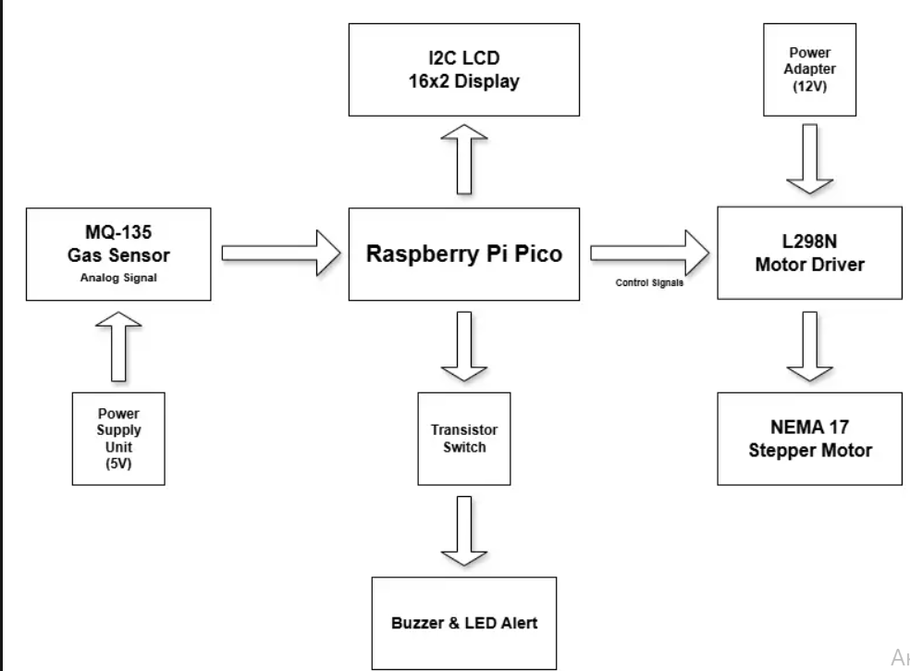

2.3 Software Structure and Functionality
The software was implemented in MicroPython running on the Raspberry Pi Pico. Its structure includes:
1. Sensor Reading Module – Continuously acquires analog voltage from the MQ-135 sensor and converts it to a normalized CO₂ concentration percentage.
2. Decision Logic – Compares the measured value against predefined thresholds (65% to open, 85% to close) with hysteresis to avoid oscillation.
3. Actuation Module – Drives the stepper motor through L298N using a half-step sequence; LED and buzzer provide feedback during movement.
4. Display Module – Updates LCD with current air quality percentage and window status (“OPEN” or “CLOSED”).
5. Alert Module – Triggers buzzer and LED signals for unsafe air quality or when window movement begins.
The software works autonomously without human intervention and is modular, allowing easy adaptation for other sensors or actuators.

2.4 Implementation and Experimental Methods
The project was developed in stages:
1. Hardware Assembly – Components were wired on a breadboard; motor and mechanical parts were integrated with the prototype frame.
2. Software Development – MicroPython code was uploaded to the Pico; sensor calibration and motor control routines were tested.
3. Integration Testing – The complete system was tested in a controlled environment with simulated CO₂ sources.
4. Performance Measurement – Air quality readings and motor responses were recorded, and timing of window actuation was analyzed.
Experimental results:
CO2 level (%) | Action taken | Response time (s) | Status
60 | None | 0 | closed
64 | Window opening | 3 | opening
86 | Window closing | 4 | closing
45 | None | 0 | open

The system demonstrated reliable operation, opening and closing the window at the correct thresholds with minimal delay, which was achieved through repeated calibration and adjustments.

2.5 Problems Encountered
During mechanical testing, the initial 3D-printed rack was incorrectly sized, preventing the window from opening smoothly. Multiple iterations of the print were required to match the motor and prototype dimensions. There were multiple versions of the software, including several adjustments, until the system performed as desired. Certain components of the frame required regluing and additional support, which was hastily fixed. Our first prototype has used LEGO pieces as a primitive and simple alternative to the later pieces we developed.

2.6 Novelty and Independence
This project integrates a low-cost sensor, microcontroller, and mechanical actuator into a compact, autonomous window control system. The solution is developed independently, including hardware assembly, software programming, and experimental testing. Unlike other solutions in literature, it is fully portable, low-cost, and designed for educational demonstration without relying on HVAC infrastructure. It’s also important to mention that we have developed an early version of a machine learning algorithm which could later be integrated into the project, allowing to predict the rise and decrease in the CO2 level and taking necessary action beforehand. The code for it will be provided in our Github.

2.7 Practical Applications
The system can be applied in:
• Homes, classrooms, or offices to maintain healthy indoor air
• Demonstration and educational purposes for learning about IoT and smart hardware
• Further integration with other sensors (temperature, humidity, VOCs) for fully automated environmental control

2.8 Illustrations
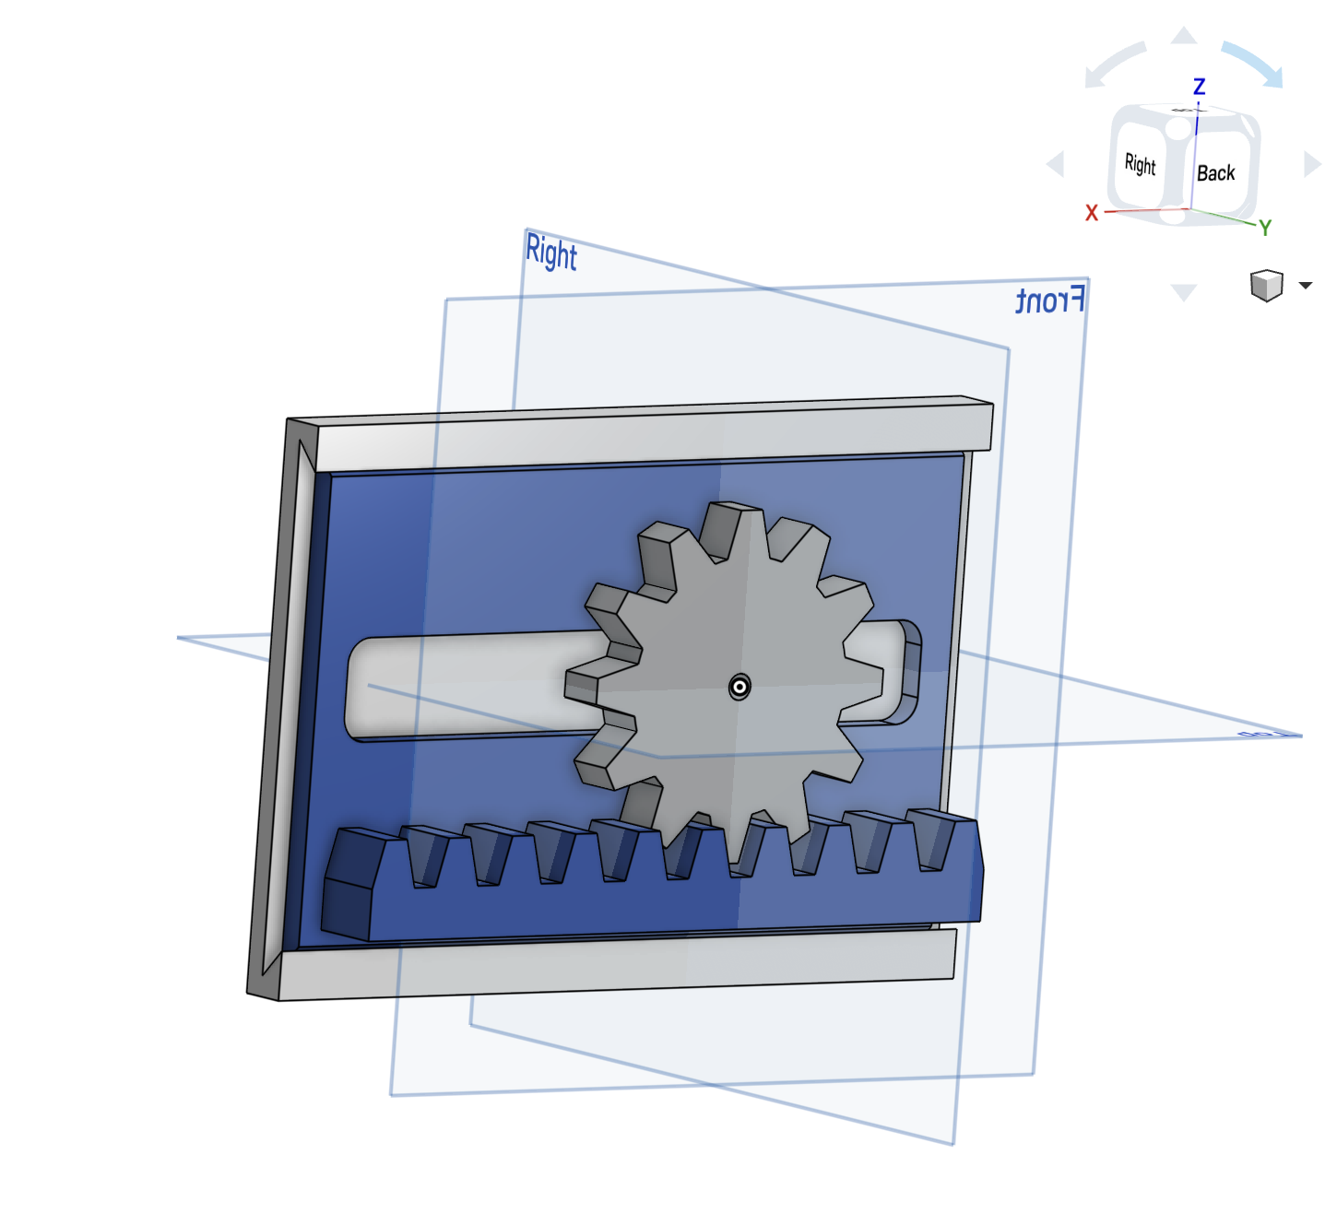

Conclusion

The project successfully developed an autonomous window control system capable of monitoring indoor CO₂ levels and actuating window movement based on real-time air-quality measurements. The system demonstrated reliable operation during testing, with precise motor actuation at defined threshold levels: opening the window when air quality fell below 65% and closing it when it exceeded 85%. The MQ-135 sensor, Raspberry Pi Pico controller, and stepper motor driver worked together to maintain healthy indoor conditions without human intervention.
The research confirmed the hypothesis that automated ventilation based on CO₂ monitoring improves indoor environmental quality and supports human well-being. Experimental results showed that the system responded promptly to changes in air quality, maintaining safe and comfortable levels within the controlled environment. Minor mechanical issues, such as initial mismatches in the 3D-printed rack size, were resolved through iterative adjustments, demonstrating the importance of precise prototyping.
The system’s design is modular, allowing future integration of additional sensors or machine learning algorithms to predict and optimize ventilation schedules. Practically, this solution can be applied in homes, classrooms, and offices to improve air quality, enhance occupant comfort, and reduce the need for manual ventilation management. The use of a low-cost sensor and microcontroller, combined with autonomous operation, demonstrates both technical feasibility and scalability.
In conclusion, the project provides a practical and innovative approach to indoor air-quality management. Recommendations include extending the system with predictive algorithms, adding temperature or humidity control, and creating more durable mechanical components for long-term use. The autonomous smart window system serves as both a functional prototype and a foundation for future enhancements in environmental control technologies.

References for Analytical Review:
[1] Li, H., Zhang, Y., & Chen, R. Smart Ventilation Control Based on CO₂ Sensing. Journal of Building Automation, 2020, 15(2), 45–52.
[2] Smith, J., & Johnson, L. IoT-Based Air Quality Monitoring and Control System. International Journal of Smart Homes, 2019, 13(4), 102–110.

